**Group 3**

**ACC311/CSC315 Project Proposal and Specifications**

**Fleet Vehicles Management**

* **Problem statement:**
  + For our project, we have been tasked with finding a more cost effective and environmentally friendly way for TCNJ’s fleet to operate
  + In order to become more cost effective and better for the environment, we suggest slowly transitioning from ICE vehicles to zero vehicles
    - By doing so over time, no large budget will need to be immediately created. Instead, money shall be allocated per year for the entire transitioning period.
    - This transition period may last 20+ years.
  + Our plan to achieve this involves retiring the older vehicles first and replacing them with zero emission vehicles.
    - This will allow for a slow, steady replacement of vehicles in order to avoid having the school have high expenses and be able to make the most use out of the current vehicle fleet before replacing them
    - This will allow newer vehicles to continue in operation, and keep replacement costs as low as possible
      * We will need to be able to keep track of costs such as fuel costs, and maintenance costs in the module to ensure that we are being cost effective as we create a more environmentally friendly fleet of vehicles
* **Objective of the module:**
  + Create a solution that addresses howTCNJ vehicle fleet composition can be economically and environmentally efficient in reducing cost and emissions.
  + A database is created which allows users to input information about the vehicle and its various attributes.
* **Description of the desired end product, and the part you will develop for this class:**
  + We hope that our final database will help us solve the problem of creating a more cost effective and eco-friendly fleet for TCNJ
    - Our database should highlight different characteristics per vehicle for the proposal/future years
    - It should also specify what vehicles will be the most cost efficient and environment safe options
  + The following elements will be major variables and output data needed to help solve the problem:
    - Fleet fuel source and emissions
    - Fleet quantity and age
    - Fleet operational costs
  + By examining the variables and outputs, we will be able to properly determine which older vehicles need to be replaced first. The database will also provide costs such as fuel costs, and maintenance costs for the vehicles
  + **Diagrammatic representation of the system boundary that specifies what data you will model and which queries you will implement**

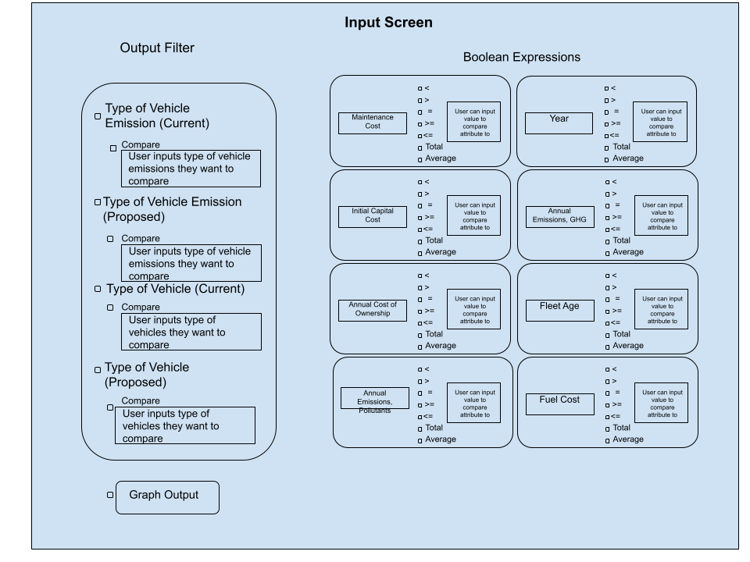

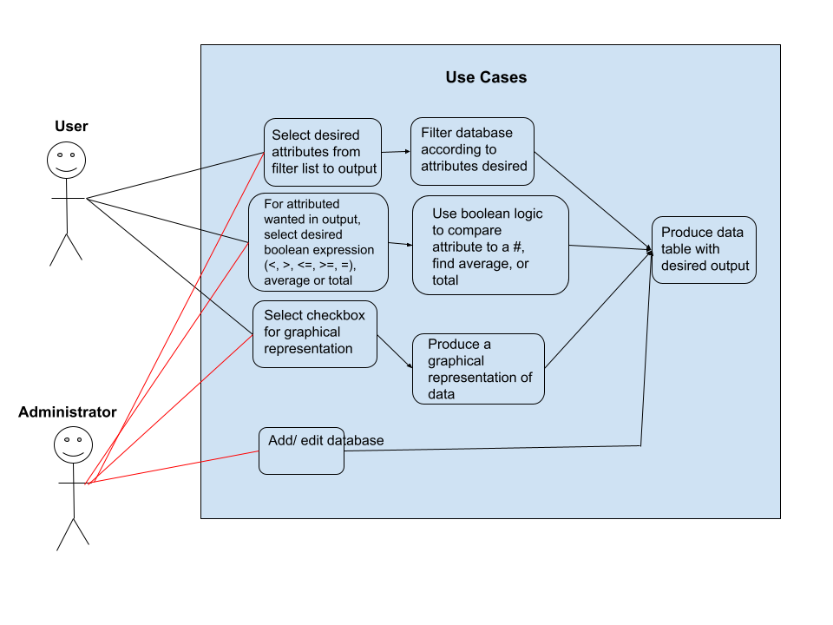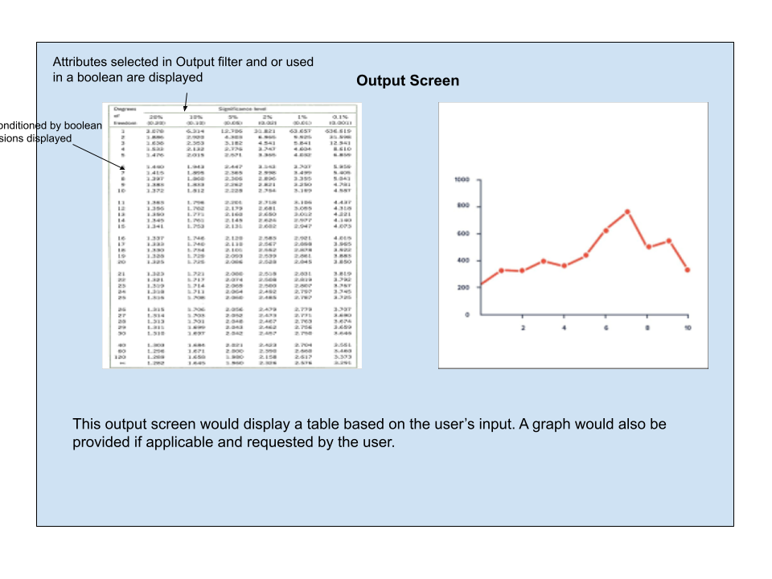

* **Description of the importance and need for the module, and how it addresses the problem:**
  + The module is necessary in addressing the problem because it provides information about how fuel source, emissions, age, quantity, and operational costs influences our solution.
  + The module will also highlight the future plans for the vehicles and add a description to the proposed vehicles being put into place.
  + Through our database, we will be able to illustrate how our plan for a slow integration of the new fleet will be the most beneficial to both TCNJ and the broader community.
  + The database will be able to show how using a FIFO method of inventory management will be a necessary process in order to replace older vehicles first, as older cars emit more emissions than more modernized vehicles.
* **Plan for how you will research the problem domain and obtain the data needed:**
  + If we were to make a full transition to zero vehicles we would need to obtain current data of charging stations already available at the school
    - This would need to include how many charging stations are currently available and where they are installed
    - We would also have to research how installing more stations would impact the cost effectiveness of our plan
      * Ex. If there are specific locations, cost constraints, other alternative power sources
    - We would also need to research how different vehicles may emit different levels of emissions as this may impact the rotation of vehicles entering and exiting the fleet and determine which vehicles should be replaced first
* **Other similar systems / approaches that exist, and how your module is different or will add to the existing system:**
  + The module is different because it will be able to search for certain characteristics and for certain vehicles.
  + The module will make it very easier to search the database to find the information that the user is looking for.
  + The module will be much better than the database provided because the module will provide a user interface that will help the user find the information they are seeking easily and it will help them find the characteristics that they are looking for on certain vehicles.
* **Possible other applications of the system (how it could be modified and reused):**
  + The model could also be used to determine the monetary cost and environmental costs of other machines/equipment in other industries
    - For example, monetary and environmental costs of certain kinds of manufacturing equipment.
* **Performance – specify how and to what extent you will address this**
  + Performance should be good since the data set for the database would not be large
  + We would try to make our database as efficient by using an ER model
    - Most importantly we would want to optimize our queries to not only allow our database to perform more efficiently but also improve its performance as a whole.
* **Security – specify how and to what extent you will provide security features:**
  + Github is a private repository not open to the public therefore it should be pretty secure when creating our database
  + Create an administrator system which would only allow those with access to edit the database thus separating the web servers from the database.
  + When the database is used by TCNJ, we would incorporate the use of administrative accounts and consumer accounts.
    - Use of password authorization
* **Backup and recovery – specify how and to what extent you will implement this:**
  + Github has backup capabilities that will allow us to be able to recover source code and update our source code.
  + Develop a backup plan, perform effective backup management and perform periodic database restore testing.
    - When our database is used by TCNJ, we would still implement the effective back management practices with periodic database restore testing.
* **Technologies and database concepts the group will need to learn, and a plan for learning these:**
  + Research:
    - Various database models to find the most efficient way to hold our data
    - How to create a user and administrator interface that supports our database
    - How to allow the user to filter the database in order to retrieve the desired information.
  + In order to achieve this our team will also need to learn how to create efficient databases.
* **1-page quad chart; see: Quad_instructions_template.ppt in the Canvas files section**

